Description
This document describes how to configure a MEET monitor
to integrate it with a Jigsaw KNX gateway
case study
MEET-ComfortClick Jigsaw KNX Integration

TABLE OF CONTENTS

INTRODUCTION 2
REQUIRED DEVICES 2
BASIC SCHEME 2
INSTALLATON 2
COMISSIONING 3
APP USAGE 5
OTHER CONSIDERATIONS 5

INTRODUCTION
The following document explains how to integrate MEET Door Entry System and KNX system, using a Jigsaw KNX gateway. Once the integration is done, control of KNX system via MEET monitor will be possible using an APP installed in the monitor.

Described steps apply to Building projects. Its main objective is to ensure the initial operation of different devices and systems, without requiring an already existing internet connection -and an installed router-, as well as avoiding additional visits from our side to finish the commissioning.

REQUIRED DEVICES
Per apartment:
- Ref. 14811 / WIT 10’’ Monitor
- Ref. 9541 / MIO/WIT connector monitor
- Ref. 7668 / MEET-HA integration router
- ComfortClick Jigsaw KNX gateway

BASIC SCHEME
Apartment 1 without an internet connection
Apartment 2 with an internet connection

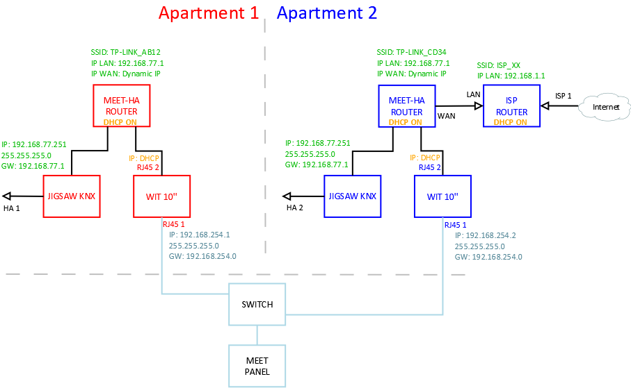

INSTALLATON
INTEGRA APP for MEET monitors: Link

COMISSIONING
Resume
- Office | Jigsaw KNX configuration | - Change default IP address to 192.168.77.251
 | Router configuration | - Connect your laptop and Jigsaw KNX to MEET-HA integration router  - Configure MEET-HA integration router IP address: 192.168.77.1
 | WIT 10’’  configuration | - Conect RJ45 1 & 2 to MEET-HA integration router  - Install the APP INTEGRA  - Open APP -> Settings: Connection to IP address 192.168.77.251
- Installation | Verifications | - Power on MEET-HA integration router and Jigsaw KNX gateway  - Connect:  - WIT 10'' RJ45 1 (left) to MEET network  - WIT 10'' RJ45 2 (right) to any LAN port of MEET-HA integration router  - Jigsaw KNX gateway to any LAN port of MEET-HA integration router  - Verifications:  - Visualization of Jigsaw KNX via WIT 10'' monitor
- Apartment | Remote control  (end user) | - ISP router installation  - Connect MEET-HA integration router WAN por to any LAN port of ISP router

Office tasks are described below.
NOTE: Described IP address changes (Jigsaw KNX & MEET-HA integration router) serves the only purpose of creating a network (192.168.77.x) which doesn’t match the default IP address of the router installed by the ISP (generally 192.168.0.x or 1.x).

- Jigsaw KNX gateway configuration

Connect Jigsaw KNX to MEET-HA router.
Required | IP address: 192.168.77.251  Gateway: 192.168.77.1

Please see bOS Configurator manual: Link
Save changes. The device will reboot with the new settings.

- MEET-HA Integration router configuration

- Connect your laptop to MEET-HA router

- Open the following link using any web browser http://192.168.1.1
User: admin; Password: admin

- Network > WAN > Confirm WAN connection type is set to “Dynamic IP”

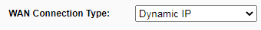

- Network > LAN > Change router IP address to 192.168.77.1 and save changes

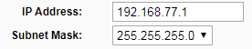
HA-MEET router will reboot.

- WIT 10’’ monitor configuration

Prerequisites:
- RJ45 1 (left) connected to MEET network (or temporarily to MEET-HA router)
- RJ45 2 (right) connected to any LAN port of MEET-HA router

- Download MEET System Upgrade Tool: Link

- Open MEET System Upgrade Tool, select INTEGRA APP (1) and adjust MEET monitor IP address range (2) to search for any MEET monitor with an IP address asigned automatically via DHCP: 192.168.77.100-105.

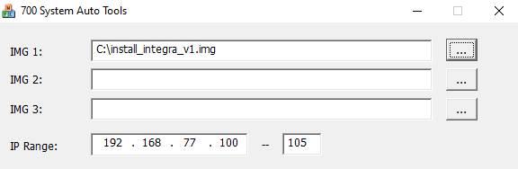
1
2

- Press “Start” to begin APP installation.

Once the monitor is detected, the APP will be installed and the monitor will reboot.

- Monitor > Go to “Installer” menu and press “APPLICATIONS” button

- Choose “INTEGRA” app, assign it an icon and saves changes.

INTEGRA APP will show in Main menu.

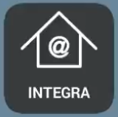

APP USAGE
Open the APP and write the URL of the HA device:
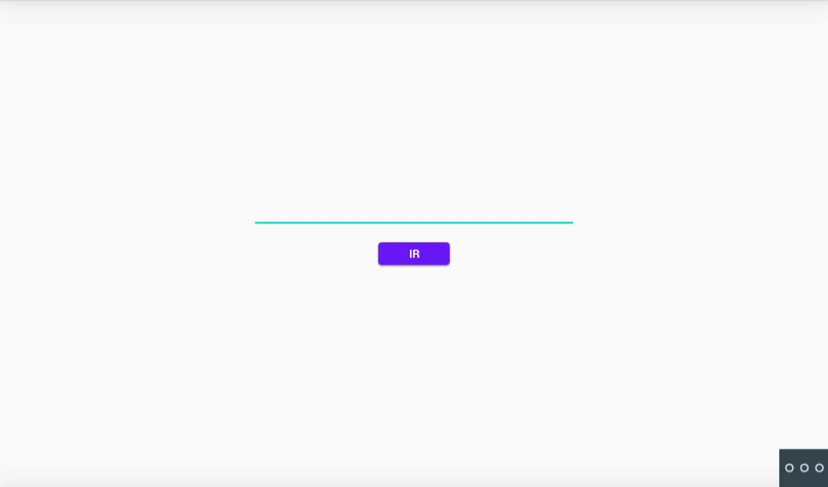
Device | URL
Jigsaw KNX | http://192.168.77.251

Press “GO”. The visualization will be shown.
In case of needing to modify the URL, please press and then

OTHER CONSIDERATIONS
FW monitor WIT: V03.00T
APP Integra v1.0
FW ComfortClick bOS: 4.8.20

